SCUBA-2 Block Specification
tx_control

Table of Contents

1. Block Overview 3
1.1 Block Location and Block Interface Within System 3
1.2 Block Functionality / Features 3
1.3 Block Dataflow 3
2. Block Interfaces 4
2.1 Interface Signal Description 4
2.2 Interface Protocol and Timing 4
3. High-Level Description 5
3.1 Block Description 5
4. Files of the Block 6
4.1 Source Code 6
4.1.1 tx_control.vhd 6

Block Overview

Block Location and Block Interface Within System
This block is located on the clock card FPGA. It interfaces with the following block on the clock card:

- tx_fifo

Block Functionality / Features
- This block controls the reading of data from the transmit fifo block “fibre_tx_fifo” to the Cypress CY7B923 HOTLinkTM transmitter (located on the clock card).

Block Dataflow

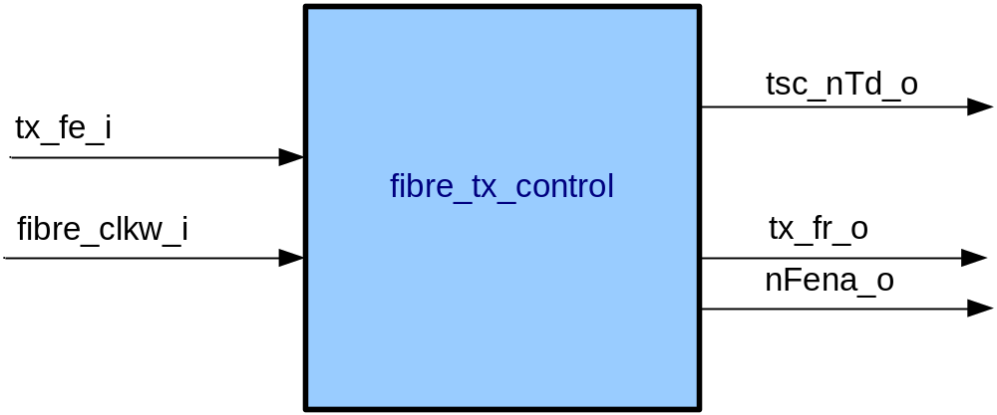

Block Interfaces

Interface Signal Description
- Interface Signals
Signal | Description | Direction
Control Signals
tx_fe_i | Transmit FIFO empty line. Indicates that the FIFO is empty and that there is nothing to be transmitted. | in
fibre_clkw_i | HOTLinkTM Tranmitter clock write. | in
tsc_nTd_o | HOTLinkTM Transmitter special character / Data select. Always transmitting data so this is held low permanently. See CY7B923 data sheet for details. | out
nFena_o | HOTLinkTM Transmitter enable parallel data. When this signal is pulled low the HOTLINK transmits a byte of data over the fibre (see datasheet for timing). | out
tx_fr_o | FIFO read enable. When asserted data is read from FIFO on the next positive edge of fibre_clkw_i. It is then available for the HOTLINK transmitter to transmit. | out

Interface Protocol and Timing

High-Level Description

Block Description

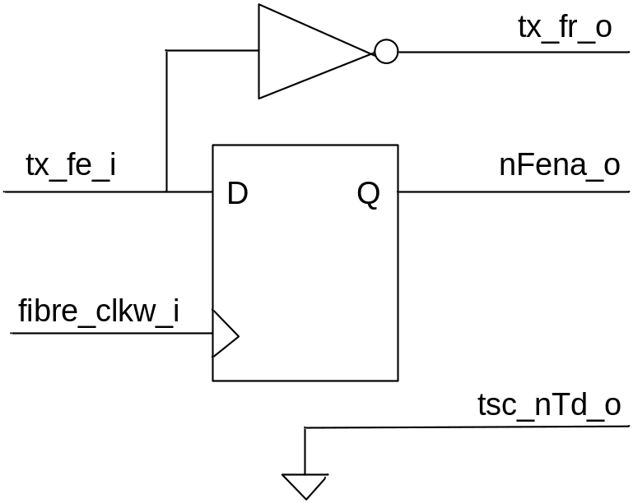

If there is a byte of data in the transmit FIFO the input signal ‘tx_fe_i’ will be LOW. When this is the case the FIFO read enable ‘tx_fr_o’ is asserted, thereby making the byte available on the next positive edge of fibre_clkw_i (see tx_fifo.doc for details). The HOTLINK transmitter enable signal ‘nFena’ is synchronised to the FIFO read but with a delay of one ‘fibre_clkw_i’ clock cycle.

Files of the Block

Source Code

tx_control.vhd

